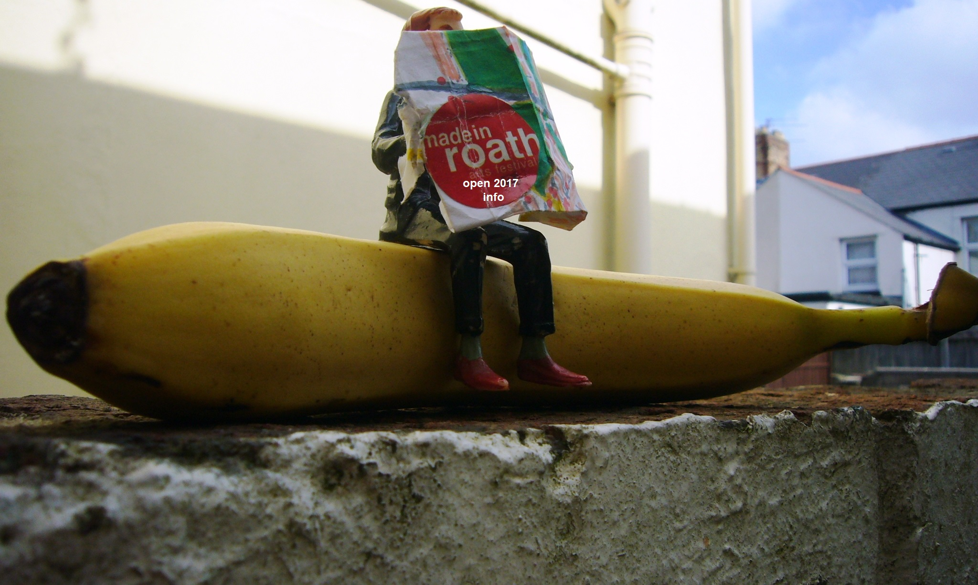
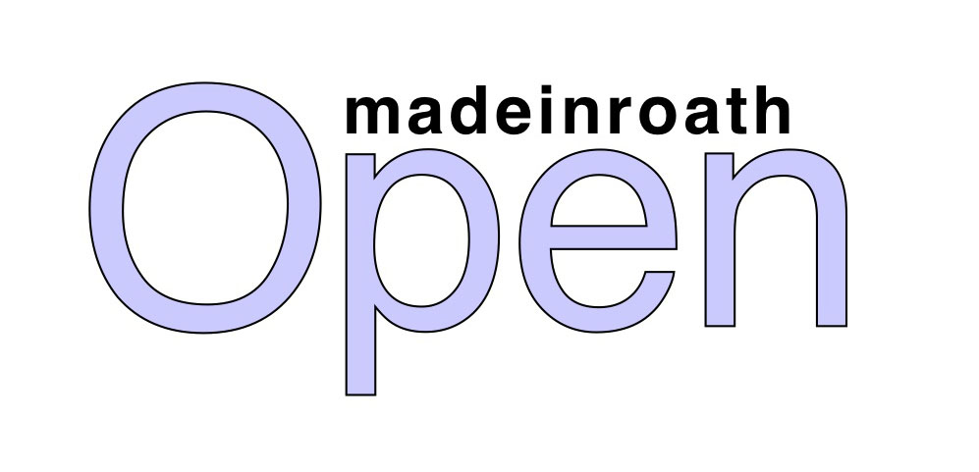

made​in​roath
Open Exhibition 15-22 Oct 2017
Preview/Festival Launch Sat 14 Oct 6pm - 8pm

MiR warmly invites you to submit work for this year’s Open Exhibition, which we are delighted to be holding ​at The Gate Arts Centre, Keppoch Street, CF24 3JW.

There is no admission fee for showing and no restrictions according to age, ability or
experience. This open call approach is a deliberate strategy and always results in an
interesting and unique exhibition.

If your work is not framed, it will be attached to the wall with removable adhesive, and
canvases need to be stretched and plated (see below for instructions). If your work is
larger than 100x100cm please contact us in advance, or if you have any queries
regarding the work you would like to submit, please email or call us on the contact
details below, and we will try our best to help.

Work for this exhibition is not required to be for sale, if it is however, there will be a 30%
commission taken which will go towards the overall costs of the show, please factor this
in when pricing your work.

Here are the key dates and details for how to submit your work:

- Monday 9 October​ between the hours of 11am - 2pm or 5 - 8pm:
Please deliver your work to the reception at The Gate. If framed or stretched, it MUST be ready to hang with mirror plates attached to the back, halfway down the vertical sides of the work. It also needs to have the required information attached (Name, Title, Media, Contact No. - see below for detachable form. If you can’t print this out, please write the info out clearly on a piece of paper and attach to your artwork).

- Saturday 14 October​ 6 - 8.00 pm:
This is The Open exhibition’s official preview, launching the made​in​roath festival 2017. Please feel free to use the opportunity to invite friends, family and colleagues to come along to view the work, enjoy a drink and stay on for an evening of art and music, which will include a free performance from the fabulous Wonderbrass in the upstairs theatre space.

- Sunday 22 October:​
Last day of the exhibition, the work will be taken down at the end of the day and stored for collection.

- Monday 23 October​:
Please collect your work from The Gate between 11am - 2pm or 5 - 8pm. If you cannot collect your work at this time, please email gail@madeinroath.com​ to arrange collection on another date, or if you are unable to collect we will do our best to deliver it. Work will only be held for a maximum of 1 week, after which we cannot guarantee its safekeeping, if you think you cannot collect it within this time please contact us in advance.

Instructions for delivering your work to The Gate:

Please cut along the dotted line and attach the following details to the back ​of your artwork.

....................................................................................

Name

Address

........................................................................Postcode

Tel Email

Artwork Title

Artwork Price (inc. 30% commission) £

Signed

By signing the above, you confirm that you agree to the madeinroath Open Exhibition
Terms & Conditions below; if your artwork does not adhere to these terms it will not be
exhibited.

Please cut along the dotted line and attach the following details to the front ​of your artwork, you can do this after wrapping.
....................................................................................

Title of Work

Artist

Medium

Total Price (inc 30% commission) £

....................................................................................

Please don't forget to put your name and contact details on the back of the artwork, this makes hanging/collating/listing the work easier for us.
Thankyou!

made​in​roath Open Exhibition 2017
Terms and Conditions

1. Display/Framing
All framed/stretched artwork needs to reach us ready to hang with mirror plates attached at the back, halfway down the vertical sides of the work. Unframed work will be pinned, or attached using adhesive from behind. If you work is larger than 100cmx100cm please contact us in advance.

2. Delivery of work
The artwork needs to reach us by the times allocated above, if you are unable to deliver your work for mobility or other reasons of access, please contact us on the email below and we will arrange to collect it for you; you will be given a receipt for your work.

3. Standard of work
All artwork should be presented to the highest quality possible and safe to hang/display.
All works submitted to the madeinroath Open Exhibition 2017 will need to be appropriate for a culturally/age related diverse audience, and we will not accept images which may cause offence, as such work will be shown at the discretion of The Gate/MiR. If for any reason you are unsure about the suitability of your work, please contact us on the email below and we can discuss your concerns.

4. Hanging of work
Hanging and exhibiting of artwork will be done by the technical team at The Gate, this year we are not able to accept anything which cannot be wall mounted; a list of works with prices will be available for viewers.

5. Collection of work
Work exhibited as part of this set date exhibition will be available for collection on the dates
specified above. If you are unable to collect the work please let us know in advance and we will try and arrange delivery.

6. Sales
Sales will be calculated at end of exhibition. The 30% commission is taken to cover
administration and hanging costs. The Gate will record and hold all monies taken until after the exhibition has closed.

Contact Details

If you have any questions at all just drop us an email at gail@madeinroath.com​

or call 07930397982

We look forward to seeing your work!

